**Handout C-4**

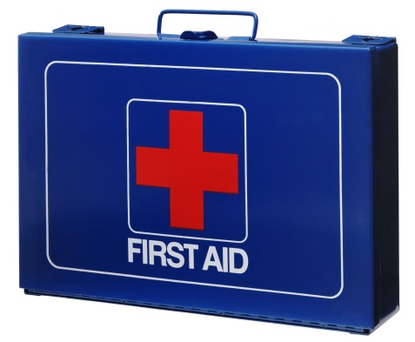 **First Aid Kit Supplies**

**Following is the list of the supplies required for your First Aid Kit. The question is, “What do I do with this?” Work with your neighbor to discuss situations when you might need to use each item in your First Aid Kit. Record your ideas.**

|  |  |
| --- | --- |
| **Required supply** | **When I might need to use this -** |
| Sterile gauze pads (2 – 4 inch sizes) |  |
| Small scissors |  |
| Band-Aids of various sizes |  |
| Roller bandages (1 – 2 inch widths) |  |
| A large triangular |  |
| Non-sterile protective gloves |  |
| Adhesive tape |  |
| Tweezers |  |
| One-way CPR barrier or mask |  |
| A current first-aid manual |  |